Sumario
Bad coding 2
Interacting with user and variables 3
Operators 4
Logical operators 5
Conditional execution 6
Loops 7
Basic functions aspects 8
Advanced functions aspects 9
Final exercises 11

Bad coding
- No matter if you don’t understand the following code, rewrite it following good practices
function pow(x,n)
{
let result=1;
for(let i=0;i<n;i++) {result*=x;}
return result;
}

let x=prompt("x?",''), n=prompt("n?",'')
if (n<=0)
{
alert(`Power ${n} is not supported, please enter an integer number greater than zero`);
}
else
{
alert(pow(x,n))
}

Interacting with user and variables

- Ask the user for his age and save it into a variable. Remember to choose a proper name and store as a number.
- Send the user a message with an advice on how his age is going to be stored.
- Ask the user for confirmation and save confirmation to a variable.
- Take the former code and add code that, by using a backticks, output his age to the console.
- What is the output of the following code?
let name = "pepe";

console.log( `hello ${1}` );
alert( `hello ${"name"}` );
alert( `hello ${name}` );

Operators
- What are the final values of all variables a, b, c and d after the code below?
let a = 1, b = 1;

let c = ++a;
let d = b++;
- What are the values of a and x after the code below?
let a = 2;
let x = 1 + (a *= 2);

- What are the results of these expressions?
console.log (5 > 4);
console.log ("apple" > "pineapple");
console.log ("2" > "12");
console.log (undefined == null);
console.log (undefined === null);
console.log (null == "\n0\n");
console.log (null === "\n0\n");
console.log ("" + 1 + 0);
console.log ("" - 1 + 0);
console.log (true + false);
console.log (6 / "3");
console.log ("2" * "3");
console.log (4 + 5 + "px");
console.log ("$" + 4 + 5);
console.log ("4" - 2);
console.log ("4px" - 2);
console.log (" -9 " + 5);
console.log (" -9 " - 5);
console.log (null + 1);
console.log (undefined + 1);
console.log (" \t \n" - 2);

- Here’s a code that asks the user for two numbers and shows their sum. It works incorrectly. The output in the example below is 12 (for default prompt values). Why? Fix it. The result should be 3.
let a = prompt("First number?", 1);
let b = prompt("Second number?", 2);

alert(a + b); // 12

Logical operators
- Explain each otuput of the following code
- Change the code inside console.log so output is true
Console.log( null || 2 || undefined );
Console.log( 1 && null && 2 );
Console.log( null || 2 && 3 || 4 );

let x = 3;

console.log((x < 5) && (x > 0));
console.log((x < 5) && (x > 6));
console.log((x > 2) || (x > 5));
console.log((x > 3) || (x < 0));
console.log(!(x == 3));
console.log(!(x < 2));
- Ask user for his age and check that it is not between 14 and 90 inclusively. Create two variants: the first one using NOT !, the second one – without it.
const numOne = 5;
const numTwo = 6;
console.log(numOne == numTwo);
- Explain what result will produce the following code
(-1 || 0) && ( 'first' );
(-1 && 0) || ( 'second' );
(null || -1 && 1) && ( 'third' );

Conditional execution
- Check if a number is odd or even
- Check if input variable is a number or not
- Find the largest of two number
- Find the largest of three number
- Check if a triangle is equilateral (all side equal), scalene (all side unequal), or isosceles (2 sides are equals)
- Find the a number is present in given range (provide start, end and number to be found)
- Check if a year is leap year or not. A leap year is 1.- divisible by 400 OR 2.- divisible by 4 and not by 100
- Rewrite the former if by using the ternary operator
- Show the number of days in a given month
- Rewrite the former if by using a switch statement
- Rewrite the former if by using && and || operators
- Will alert be shown?
if ("0") {
alert( 'Hello' );
}
- Rewrite the following code to optimize it (do not use switch). Rewrite again the following code by using a switch statement

let a = +prompt('a?', '');

if (a == 0) {
alert( 0 );
}
if (a == 1) {
alert( 1 );
}

if (a == 2 || a == 3) {
alert( '2,3' );
}

Loops
- What is the last value output by this code? Why?
- Rewrite the following code changing the for loop to while without altering its behavior (the output should stay same).
let i = 3;

while (i) {
Console.log( i-- );
}
- Write a loop which keeps prompting for a number until it is greater than 100 or enters an empty line.
for (let i = 0; i < 3; i++) {
Console.log ( `number ${i}!` );
}
- Using while loop, create two arrays: one with even numbers and another one with odds numbers. Both of them from 1 to n, being n a number provided by user. Using a for loop, create a third array whose n^{th} number is the sum of n^{th} number of both arrays.
- Write code which outputs prime numbers from 1 to n, being the latter a numbrer provided by user.
- Take odd numbers array and remove the prime numbers from it. Tip: as we have not seen array methods yet, the only way is to create a new array without those numbers
- Ask the user for a number n. Create an array of n random numbers and print the highest one. Use the following code to generate a random number between 0 and 9999
Math.floor(Math.random() * 9999)
- Ask the user for a string and print it reversed
- Ask the user for a number. Print a isosceles triangle made of asterisks with as many levels as the number the user entered.
- Ask the user for a number between 3 and 25. Calculate its factorial.
- Ask the user for a string and write a program that checks if it is palindrome (it is spelled the same forward and backward).
- Use the following code to generate a random pin number of 4 digits. Write code to allow a user to try to guess the number in 4 attempts
let numeroAleatorio = Math.floor(Math.random() * (9999 - 1000 + 1)) + 1000;

Basic functions aspects
Since we have not talked yet about native JavaScript objects, like Math, usage of Math methods, as sqrt or pow, is not allowed
- Take loop exercises from 4 until the last one and rewrite them by using functions
- Write a function sqrt(x) that returns the square of x
- Rewrite sqrt function as an expression function
- Rewrite sqrt function as an arrow function
- Write a function pow(x,n) that returns x in power n. Ask the user fot both numbers.
- Rewrite pow function as an expression function
- Rewrite pow function as an arrow function
- Write a function min(a,b) which returns the least of two numbers a and b.
- Rewrite min function as an expression function
- Rewrite min function as an arrow function
- Replace Function Expressions with arrow functions in the code below:
- Write a function named calculateSupply that:
function ask(question, yes, no) {
if (confirm(question)) yes();
else no();
}

ask(
"Do you agree?",
function() { alert("You agreed."); },
function() { alert("You canceled the execution."); }
);
  - takes 2 arguments: age, amount per day.
  - calculates the amount consumed for rest of the life (based on a constant max age).
  - outputs the result to the screen like so: "You will need NN to last you until the ripe old age of X"
Express it as an arrow function, if possible
- Create a function that greets the user by his name and with a message according to the moment of the day (morning, afternoon, night). It accepts two parameters: user name and a callback function.
Create a function that accepts three parameters: two numbers and the mathematical operation to be performed with these numbers. The following mathematical operations must be supported: addition, subtraction, division and multiplication. Use callback functions.

Advanced functions aspects
- Write the recursive version of the function square
- Write the autoexecutable version of the previous version
- Write the recursive version of the function pow
- Write an iterative and recursive function to add the n^{th} first prime numbers.
- Write an iterative and recursive function to calculate factorial of a given number
- Write a recursive function to check if a number is prime
- Rewrite the previous function to be autoexecutable
- Create a function that accepts an undetermined number of words and returns a string with all these words concatenated.
- Create a function that accepts three parameters: two numbers and a function that indicates the operation to be applied to the numbers: division or pow.
- Check the following code and explain the output
- Check the following code and explain the output
let a=b=5;
function calcula() {
console.log(a*b);
}
a=b=10;
calcula();
- Check the following code and explain the output
function crearCoche() {
let marca= "Tesla";

return function() {
return nombre;
};
}

let marca = "MG";
let coche = crearCoche();
coche();
- Check the following code and explain the output
function coche(aux){
let nombre=aux;
return function(){
return nombre;
}
}

let coche1=coche("tesla");
let coche2=coche("mg");
console.log(coche1());
console.log(coche2());
let animal = "gato";

if (1) {
let animal = "conejo";
function habla() {
if (animal1==”conejo”){
console.log(“Los conejos no hacen ruido”);
}else{
console.log (“Los gatos maúllan”);
}
}
}

habla();

Final exercises
- Make a Script that first prompts the user for a number and then present a menu allowing him to choose among geometrical figures: diamond, square or triangle. It must print, by using asterisks, the geometrical figure of his choice made of the number of files he entered.
- Make a script that makes the same, but the geometrical figure must be empty. Only the borders are made of asterisks
- Make a script that prompts the user with a number to calculate the factorial. Do it in the traditional and recursive way.
- Make a script that calculates the odds of winning a lottery according to the following formula:
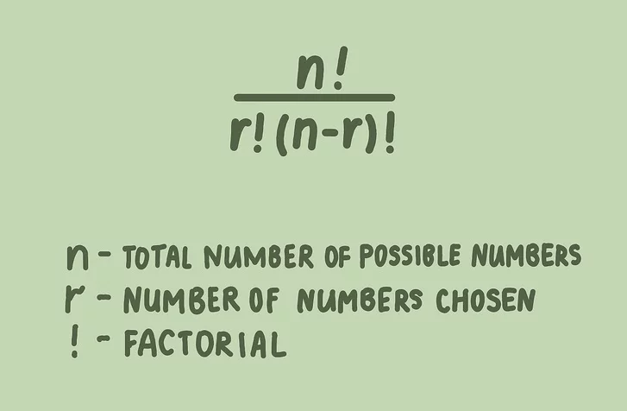
- Create a script that prompts the user with a number and calculates the sum from 1 to this number. Do it recursively.
- Create a script that prompts the user with a number and calculates the number of digits. Do it recursively.
- Create a script that prompts the user with a number and prints it in reverse order.

